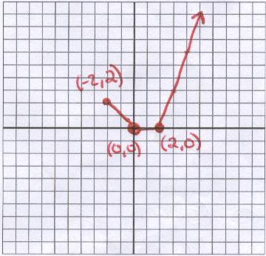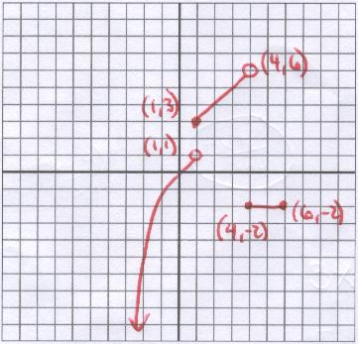

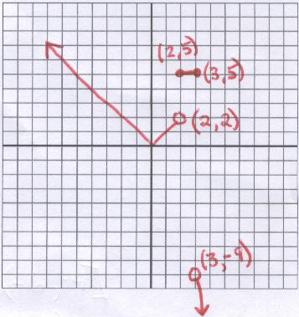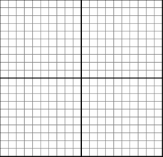
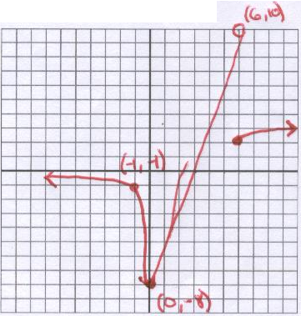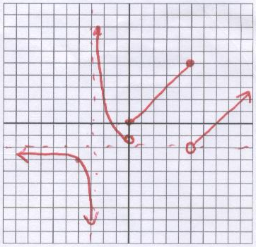

$f\left(x\right)=\left\{\begin{matrix}4x−9, −∞<x≤0 \\ x^{2}\text{-8, }0<x≤4 \\ \sqrt{x}+1,\text{ 4}<x<∞\end{matrix}\right.$ $g\left(x\right)=\left\{\begin{matrix}x^{3}, \left(−∞,1\right) \\ x+2, [\text{1,}4) \\ −2, \left[4,6\right]\end{matrix}\right.$

$h\left(x\right)=\left\{\begin{matrix}\frac{1}{x}, \left(−∞,0\right) \\ |x|, [\text{0, 5}] \\ \text{x-7 , }(\text{5, }∞)\end{matrix}\right.$ $f\left(x\right)=\left\{\begin{matrix}4x−9, −∞<x≤0 \\ x^{2}\text{-8, }0<x≤4 \\ \sqrt{x}+1,\text{ 4}<x<∞\end{matrix}\right.$

$g\left(x\right)=\left\{\begin{matrix}\frac{1}{x}, \left(−∞,0\right) \\ 3x−8, [\text{0,}6) \\ \sqrt{x−2}\text{ , }[\text{6, }∞)\end{matrix}\right.$ $h\left(x\right)=\left\{\begin{matrix}\frac{1}{x}, \left(−∞,0\right) \\ |x|, [\text{0, 5}] \\ \text{x-7 , }(\text{5, }∞)\end{matrix}\right.$

